PROBLEM 1: PERSON CLASS AND OBJECT SWAPPING
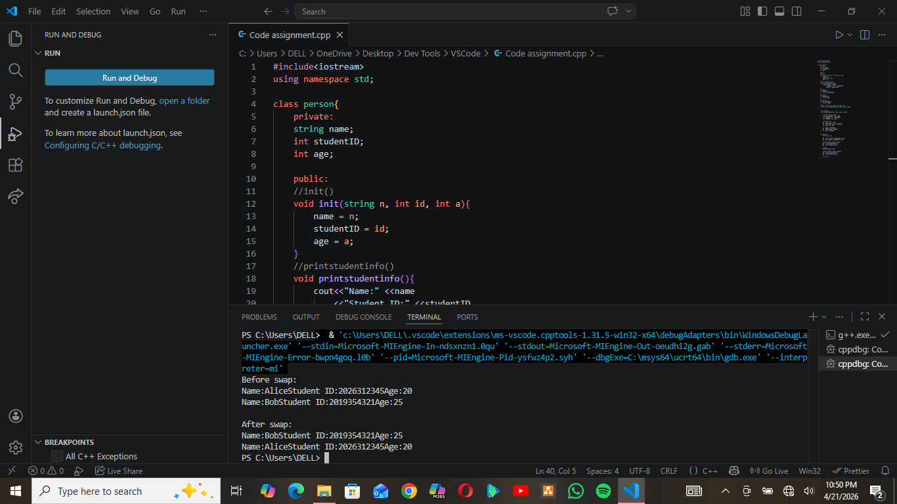
This code is used to design a Person class that stores the name, student ID and age. It also displays stored information and provide access to individual values and then swap the data of two objects.

Concepts Applied
- Encapsulation: Data members are private and accessed through functions
- Member functions: Operate on object data
- Pass-by-reference: Allows direct modification of objects
- Friend function: Grants external function access to private members

Functionality Explanation
init()
This function initializes the object by assigning input values to its private variables. It acts as a manual constructor and ensures each object stores its own independent data.

printStudentInfo()
Displays the stored information in a formatted way. It accesses private variables directly since it is a class member and ensures consistent output formatting.

Getter Functions (getID, getAge, getName)
These functions return specific values from the object.
They provide controlled access to private data.
Prevent direct external modification of variables.

personSwap()
This function swaps the contents of two Person objects.
string tempName = p1.name;
p1.name = p2.name;
p2.name = tempName;
How it works
- Temporary variables store values of the first object.
- Values from the second object are copied into the first.
- Stored temporary values are assigned back to the second object.

PROBLEM 2: DYNAMIC 2D SEAT MAP
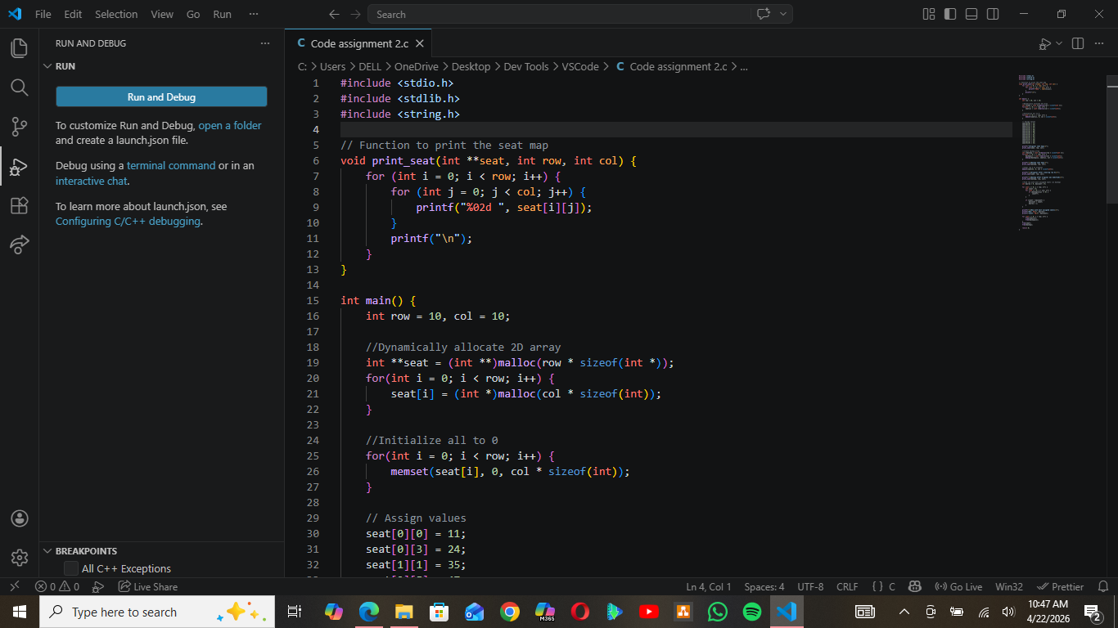

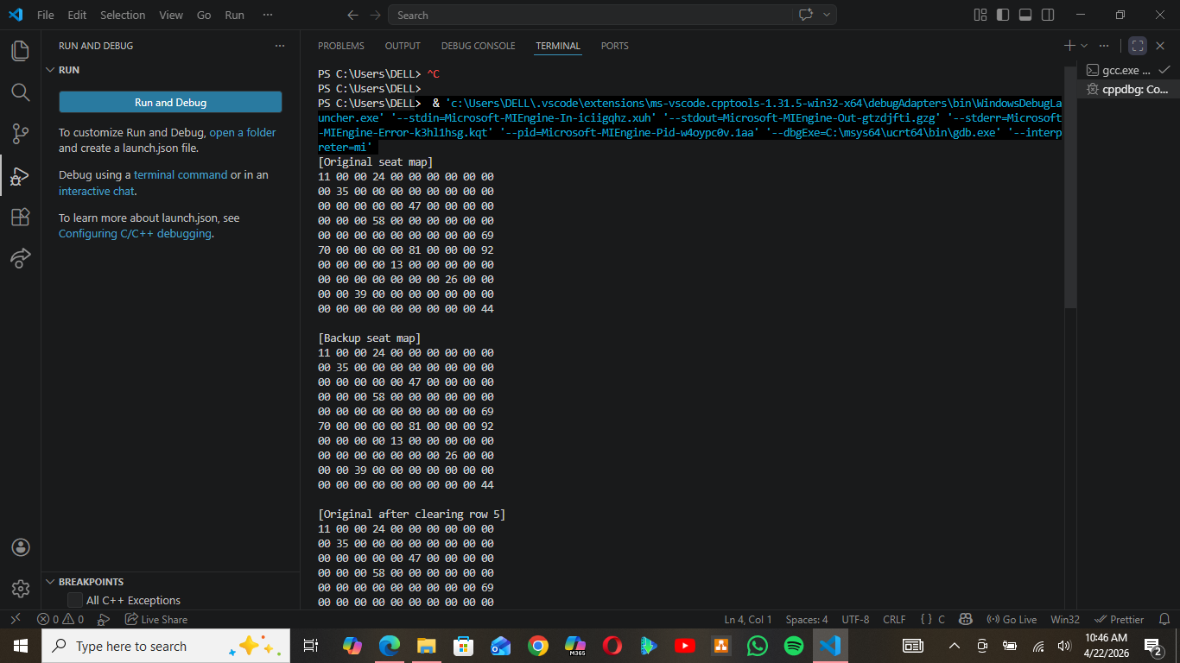

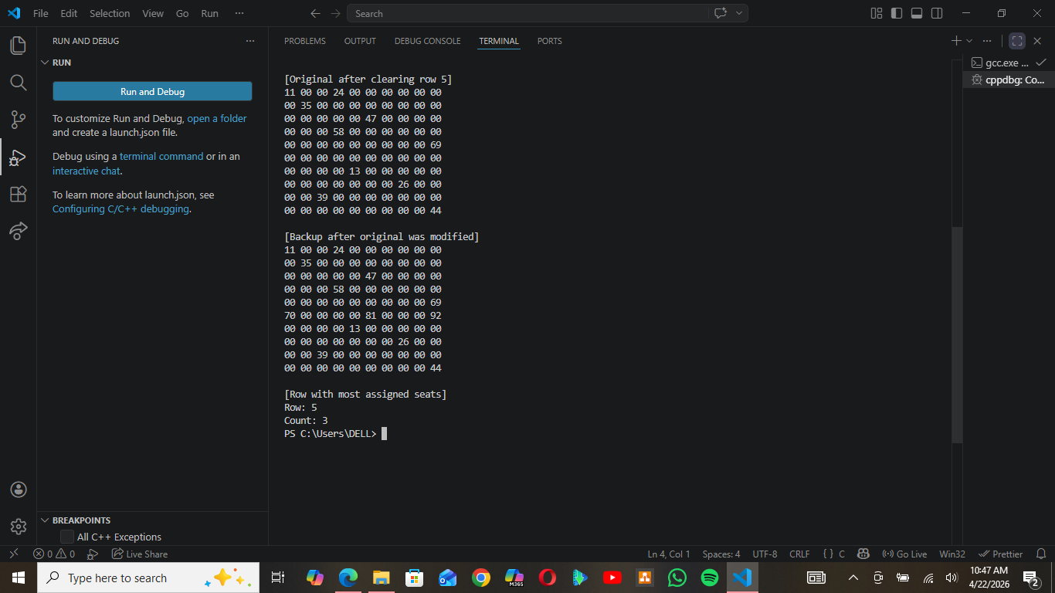
This code is used to implement a seat management system using a dynamically allocated 10x10 integer array, memory initialization and cleanup.

Concepts Applied
- Dynamic memory allocation (malloc)
- 2D arrays using pointers (int**)
- Memory initialization (memset)
- Memory copying (memcpy)
- Manual memory deallocation (free)

Code Structure Overview
Dynamic Allocation
int **seat = (int **)malloc(row * sizeof(int *));
for (int i = 0; i < row; i++) {
seat[i] = (int *)malloc(col * sizeof(int));
}
- First allocates memory for row pointers.
- Each pointer is then assigned memory for columns.
- This creates a structure equivalent to a 2D array.

Initialization with memset
memset(seat[i], 0, col * sizeof(int));
- Sets all values in a row to 0.
- Ensures the array starts in a known state.
- More efficient than using nested loops.

Copying with memcpy
memcpy(backup[i], seat[i], col * sizeof(int));
- Copies data from one row to another.
- Must be done row by row because memory is not continuous.
- Produces a deep copy, meaning both arrays are independent.

Modifying Original Array
memset(seat[5], 0, col * sizeof(int));
- Clears all values in row 5.
- Demonstrates that only the original array changes.

Finding Row with Maximum Values
if (backup[i][j] != 0) count++;
- Counts assigned seats (non-zero values).
- Compares counts to find the row with the highest number.

Memory Deallocation
free(seat[i]);
free(backup[i]);
free(seat);
free(backup);
- Frees each allocated row first.
- Then frees the array of pointers.
- Prevents memory leaks.

PROBLEM 3: STRING DICTIONARY USING CHAR**
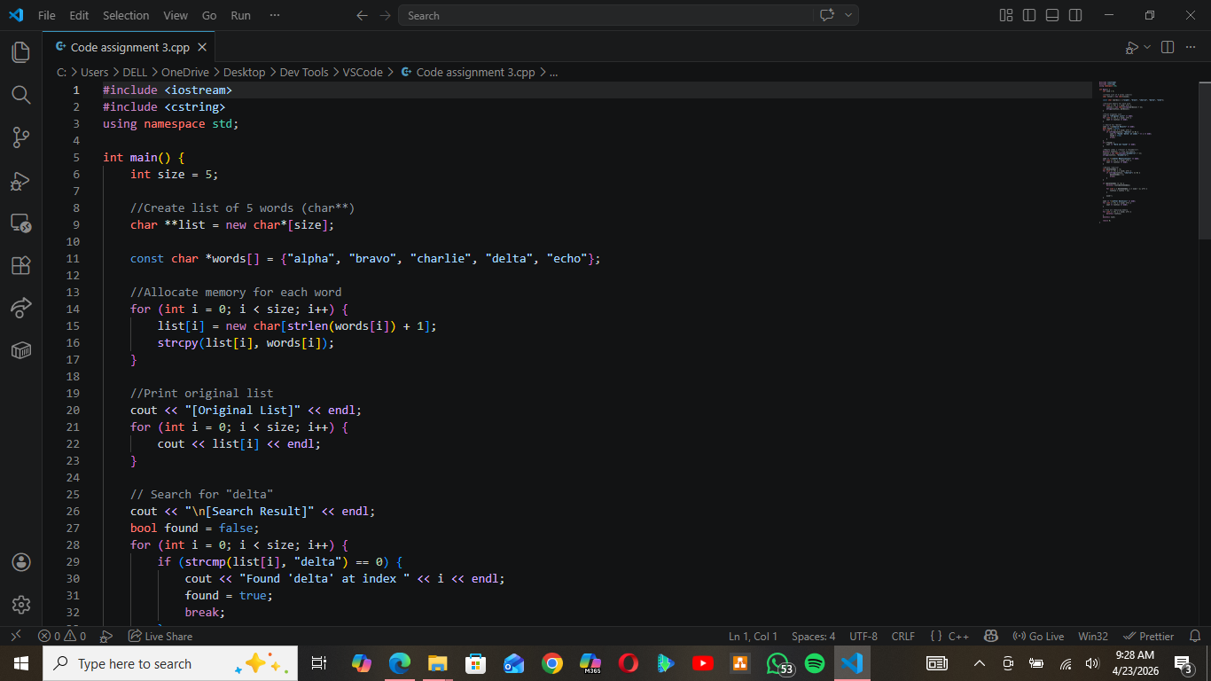
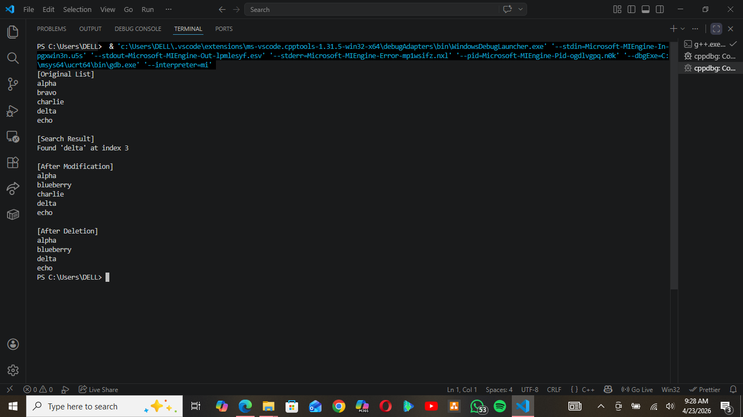

This code is used to create a dictionary system that stores strings using dynamic memory. It also performs search, update and deletion operations and manages memory.

Concepts Applied
- Pointer to pointer (char**)
- Dynamic string allocation
- String handling functions (strlen, strcpy, strcmp)
- Manual memory management

Code Structure Overview
Creating the List
char **list = new char*[size];
- Allocates memory for an array of string pointers.
- Each pointer will later store a word.

Allocating and Copying Strings
list[i] = new char[strlen(words[i]) + 1];
strcpy(list[i], words[i]);
- Allocates exact memory required for each string.
- +1 accounts for the null terminator (\0).
- strcpy copies the actual content into allocated memory.

Searching for a Word
strcmp(list[i], "delta") == 0
- Compares string contents character by character.
- Required because == compares memory addresses, not content.

Modifying a Word
delete[] list[1];
list[1] = new char[strlen("blueberry") + 1];
strcpy(list[1], "blueberry");
- Frees previously allocated memory.
- Allocates new memory for the updated word.
- Prevents memory leaks and ensures correct storage.

Deleting a Word
delete[] list[index];
for (int i = index; i < size - 1; i++) {
list[i] = list[i + 1];
}
size--;

Memory for the deleted word is freed.
Remaining elements are shifted left to fill the gap.
Size is reduced to reflect the updated list.

Memory Cleanup
for (int i = 0; i < size; i++) {
delete[] list[i];
}
delete[] list;
- Ensures all allocated memory is released.
- Prevents memory leaks.

